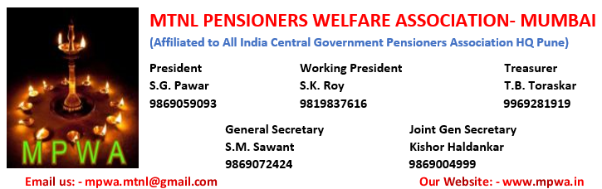
No. MPWA/PM/Pensioner’s dues/2020 dated at Mumbai, the, 15th August 2020
To.
Hon’ble Narendra Modiji,
The Prime Minister of India, New Delhi.
Sub:- Non receipt of pensionary benefits from MTNL Mumbai reg……
Respected Sir
With due respect and Honor, I undersigned would like to bring to kind notice that,
Before touching the subject, I take this opportunity to congratulate you to address the Nation consequently sixth time, on the eve of 73rd Independence Day of our beloved India.
Respected Sir, In MTNL Mumbai the employees who have retired on superannuation have been deprived from there pensionary benefits for one other reason. The various DoPT orders issued in this regard also not followed and implemented. This issue was brought to the notice of various authorities of MTNL but still favorable action is awaited.
Sir, everyone is aware that the salary income will stop immediately on retirement , and if pensionary benefits are not received the pensioners has to depend on some one for their day to day .But MTNL Administration does have any sympathy towards their workers who retired after serving MTNL for more than 30/35 years. Further during present COVID 19 situation & lockdown period, pensioners/Sr. Citizens who are vulnerable to Covid 19, are advised not to move out, which is another blow to them. In MTNL Mumbai number superannuation retires are waiting for their retirement benefit and pension.
Further I take this opportunity to inform you that sir , The commitments of VRS 19 in MTNL are not fulfilled by MTNL management in realizing of VRS / Pensionary benefits. Due to which the VRS optees plan, commitments and there day to day need are hampered badly.

Continue on Page No 2.
2
Under the circumstances, we would like to appeal to you look into the matter personally and direct the MTNL Mumbai Management to pay all the due of all the retirees immediately so that MTNL Pensioners can get relief and breath comfortably after their retirement. I express my sincere apology for encroaching upon your valuable time Since you have number of national/international issues before you, .
With High Regards,
Yours sincerely,
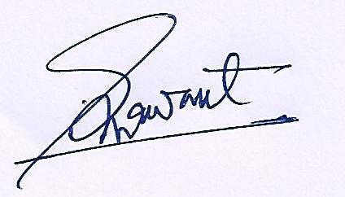
Copy to:- S. M. Sawant
- Secretary Pension/DoT Genl. Secretary, MPWA
- Dir (HR & I/c Comm. Of Functional Directors), MTNL CO
- Shri. V. Sri Shankar, Executive Director, MTNL Mumbai

